**Hydrosocial Cycle:**

Socio-natural process by “which water and society make and remake each other over space and time”-Linton & Budds

Water cycle→water system(cycle+biological+biogeochemical+human)

How instances of water become produced, and how produced water reconfigures social relations.Unravelling this historical and geographical process of making and remaking offers analytical insights into the social construction and production of water, the ways by which it is made known, and the power relations that are embedded in hydrosocial change.

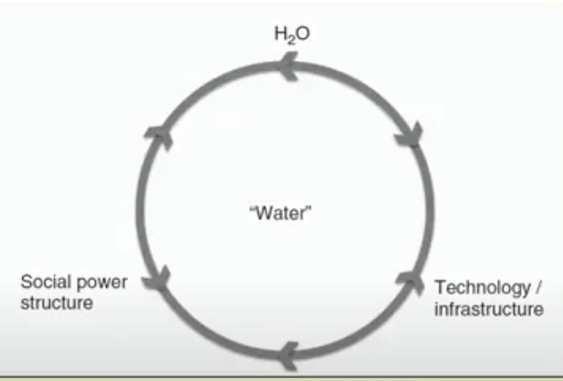

Different instances of water:

Dam:

State-run utility, construction

Deasalined Water:

Peru

Groundwater: